**Stage 1: AWS Environment Setup**

1. Navigate to <https://aws.amazon.com/free/> and set a free account (credit card information must be provided on step 3 of 5-step-verification process)
2. Login to AWS with received credentials
3. Navigate to AWS > Services and search for EC2.
4. Choose EC2 instance:   
   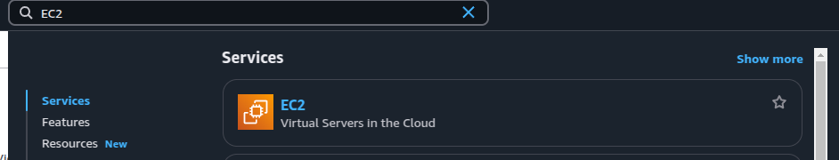
5. Create EC2 instance with the following parameters:   
   1. **Name**: Choose a meaningful name.
   2. **Amazon Machine Image (AMI)**: Use **Ubuntu 22.04 LTS** or **Amazon Linux 2**.
   3. **Instance Type**: Choose **t3.micro** (Free Tier eligible).
   4. **Key Pair**: Create/download a key pair if you don’t have one.
   5. **Security Group**:
      1. Allow **SSH (port 22)** for your IP.
      2. Allow **HTTP (port 80)** for public access.
      3. Allow **HTTPS (port 443)** if using SSL.
   6. Click **Launch**.
6. On your computer (Linux, terminal/Windows, Putty) run command to connect to AWS machine:   
   ssh -i your-key.pem ubuntu@your-ec2-public-ip (you can pick up public address of your AWS instance in ECS > Dashboard > Instances)
7. Install Apache server by running following sequence of commands:
   1. sudo apt update
   2. sudo apt install apache2 -y
   3. sudo systemctl enable apache2
   4. sudo systemctl start apache2
8. Verify: Visit **http://your-ec2-public-ip** in a browser to see a public Apache landing page
9. Create an index.html file:   
   echo '<h1>Hello from Julia on EC2!</h1>' | sudo tee /var/www/html/index.html  
   